



Society for Computer Technology & Research’s

Pune Institute of Computer Technology
Dhankawadi, Pune-411043
Community Engagement Project Academic Year: 2026-27
An Autonomous Institute affiliated to the Savitribai Phule Pune University (SPPU)
Department of

Attendance & Assessment Record

Semester: | III
Class: |  | Batch:
Course: | [0313201] Community Engagement Project

Name of the Faculty:
Department of Computer Engineering
PICT, Pune

Society for Computer Technology & Research’s

Pune Institute of Computer Technology
Dhankawadi, Pune-411043
Department of

Task to perform and schedule

Sr. No. | Task | Performance Date  Scheduled | Submission Date  Scheduled
Week-01 | Group formation and Idea Initiation | 20/07/26 | 27/07/26
Week-02 | Feasibility study and list of resources required | 27/07/26 | 31/07/26
Week-03 | Communication with internal authorities and  external organization | 31/07/26 | 07/08/26
Week-04 | Start of activity after receiving necessary approvals | 07/08/26 | 14/08/26
Week-05 | Report status of activity | 14/08/26 | 21/08/26
Week-06 | Report status of activity | 21/08/26 | 28/08/26
Week-07 | Report status of activity | 28/08/26 | 4/09/26
Week-08 | Report status of activity | 04/09/26 | 11/09/26
Week-09 | Mid semester assessment | 11/09/26 | 18/09/26
Week-10 | Report status of activity | 18/09/26 | 25/09/26
Week-11 | Report status of activity | 25/09/26 | 1/10/26
Week-12 | Report status of activity | 1/10/26 | 06/10/26
Week-13 | Final report writing and presentation | 06/10/26 | 13/10/26
Week-14 | Submission, conclusion and assessment. | 13/10/26 | 20/10/26

Broad Category of Activity (✓ Tick appropriate) Refer Syllabus
□ | Education and Awareness | □ | Technology for Social Good
□ | Environmental Sustainability | □ | Health and Wellness
□ | Skill Development | □ | Culture & Heritage

Course Objectives: The objective of this course is to provide students with
- Opportunities to engage with their local community, fostering empathy, teamwork, and problem-solving skills while contributing positively to their surroundings.
- An understanding of the challenges faced by the local community and the role of engineering in addressing those challenges.
- The ability to apply technical knowledge and skills to design solutions or interventions that create a positive impact on the community.
- The skills to evaluate and critically analyze the outcomes of their engagement activities, deriving actionable insights for sustainable impact.
Course Outcomes: After completing this course, students will be able to
0313201-1: Identify and Analyze community needs and challenges by engaging with stakeholders and evaluating real-world problems (BTL: L1: Remember, L4: Analyze).
0313201-2: Design and Implement practical, creative, and context-specific solutions using engineering principles to address community issues (BTL: L1: Apply, L6: Create). 0313201-3: Reflect and evaluate the effectiveness of their interventions and articulate lessons learned through reports and presentations (BTL: L2: Understand, L5: Evaluate).

Articulation matrix mapping of CO with revised PO:

Course Outcomes (COs) | PO1 | PO2 | PO3 | PO4 | PO5 | PO6 | PO7 | PO8 | PO9 | PO10 | PO11
CO1 | 2 | 3 | 1 | 2 | 1 | 3 | 2 | 2 | 1 | 1 | 2
CO2 | 2 | 2 | 3 | 2 | 2 | 3 | 2 | 3 | 2 | 2 | 2
CO3 | 1 | 2 | 1 | 2 | 1 | 2 | 2 | 2 | 3 | 1 | 3

Activity Log book
CEP Activity Title:

Host Organization name and address:

Roll  No. | Examination  number: | Student Name: | Mobile no and email address
1
2
3
4
5

Week number | Total no. of  hours | Task carried out | Students Signature  with date | Remark and Teacher Signature  with date
1 | 2 | Introduction about course, Group formation and Idea Initiation
2 | 2 | Feasibility study and list of resources required
3 | 2 | Communication with authorities from internal and external organization
4
5
6
7
8
9
10
11
12
13
14
Final Submission & Verification
Total Hours Completed:

Faculty Coordinator Name & Signature

COMMUNITY ENGAGEMENT PROJECT – ACTIVITY PROPOSAL FORM
- Basic Information
  - Title of the Activity:

  - Proposed by (Student/Faculty/Team):

  - Department:
  - Date of Proposal:
  - Duration of Activity:

- Project Details
  - Community Need Identified:(Briefly describe the problem/need addressed by the project)

  - Objective of the Activity: (State the purpose and expected contribution to the community, 3 Objectives)
1.

2.

3.

- Proposed Beneficiaries: (Specify group: e.g., school students, senior citizens, women groups, etc.)

- Proposed Venue/Location:
- Nature of Engagement:
[ ] Awareness Program [ ] Skill Development
[ ] Demonstration / Workshop [ ] Socio-Technical Solution [ ] Other:
- Implementation Plan
  - Description of Activity:(Outline steps, timeline, and approach)

  - Resources Required: (List Manpower, materials, tools, permissions, etc.)

  - Estimated Budget:
  - Stakeholders / Partners:
  - Faculty Coordinator(s):
- Expected Outcomes (List measurable and qualitative benefits for community and students)

- Risk & Mitigation Plan (Identify possible risks & measures to minimize them)

- Approvals
  - Student Team Leader: Date:
  - Faculty Coordinator: Date:
  - HoD / CEP Coordinator: Date:
- Target SDG’s
The 17 Sustainable Development Goals (SDGs) adopted by the United Nations in 2015 as part of the 2030 Agenda for Sustainable Development: (✓ Tick appropriate)
- No Poverty – End poverty in all its forms everywhere.
- Zero Hunger – End hunger, achieve food security and improved nutrition, and promote sustainable agriculture.
- Good Health and Well-being – Ensure healthy lives and promote well-being for all at all ages.
- Quality Education – Ensure inclusive and equitable quality education and promote lifelong learning opportunities for all.
- Gender Equality – Achieve gender equality and empower all women and girls.
- Clean Water and Sanitation – Ensure availability and sustainable management of water and sanitation for all.
- Affordable and Clean Energy – Ensure access to affordable, reliable, sustainable, and modern energy for all.
- Decent Work and Economic Growth – Promote sustained, inclusive, and sustainable economic growth, full and productive employment, and decent work for all.
- Industry, Innovation, and Infrastructure – Build resilient infrastructure, promote inclusive and sustainable industrialization, and foster innovation.
- Reduced Inequalities – Reduce inequality within and among countries.
Sustainable Cities and Communities – Make cities and human settlements inclusive, safe, resilient, and sustainable.
- Responsible Consumption and Production – Ensure sustainable consumption and production patterns.
- Climate Action – Take urgent action to combat climate change and its impacts.
- Life Below Water – Conserve and sustainably use the oceans, seas, and marine resources for sustainable development.
- Life on Land – Protect, restore, and promote sustainable use of terrestrial ecosystems, manage forests sustainably, combat desertification, and halt biodiversity loss.
- Peace, Justice, and Strong Institutions – Promote peaceful and inclusive societies, provide access to justice for all, and build effective, accountable institutions.
- Partnerships for the Goals – Strengthen the means of implementation and revitalize the Global Partnership for Sustainable Development.

COMMUNITY ENGAGEMENT PROJECT – FEASIBILITY STUDY TEMPLATE

Section | Questions / Criteria | Remarks / Findings
1. Project Relevance | Does the activity address a genuine community need?
 | Is it aligned with course/community engagement objectives?
2.Technical Feasibility | Do we have the skills/expertise to execute it?
 | Are resources, tools, and equipment available?
3. Financial Feasibility | What is the budget requirement?
 | Are there funding sources (college, sponsors, contributions)?
4. Logistical Feasibility | Is the location accessible and safe?
 | Are permissions required? If yes, can they be obtained?
5. Time Feasibility | Can the project be completed in the proposed timeframe?
 | Is it compatible with academic schedules?
6. Risk Assessment | Identify potential risks (e.g., safety, legal, social sensitivity).
 | Define risk mitigation strategies.

Evaluation and assessment
Criteria | Roll no | Excellent 5 | Very Good 4 | Good 3 | Fair 2 | Poor 1
1. Problem Identification & Social Relevance (20%) | 1
1. Problem Identification & Social Relevance (20%) | 2
1. Problem Identification & Social Relevance (20%) | 3
1. Problem Identification & Social Relevance (20%) | 4
1. Problem Identification & Social Relevance (20%) | 5
2. Planning, Execution,  and teamwork (20%) | 1
2. Planning, Execution,  and teamwork (20%) | 2
2. Planning, Execution,  and teamwork (20%) | 3
2. Planning, Execution,  and teamwork (20%) | 4
2. Planning, Execution,  and teamwork (20%) | 5
3. Community Engagement and Impact (20%) | 1
3. Community Engagement and Impact (20%) | 2
3. Community Engagement and Impact (20%) | 3
3. Community Engagement and Impact (20%) | 4
3. Community Engagement and Impact (20%) | 5
4. Application and  expertise (20%) | 1
4. Application and  expertise (20%) | 2
4. Application and  expertise (20%) | 3
4. Application and  expertise (20%) | 4
4. Application and  expertise (20%) | 5
5. Documentation &  Presentation (20%) | 1
5. Documentation &  Presentation (20%) | 2
5. Documentation &  Presentation (20%) | 3
5. Documentation &  Presentation (20%) | 4
5. Documentation &  Presentation (20%) | 5

Remarks or any special achievements may be listed here.

Students’ Feedback form after activity
Each student/ group shall submit this form (soft and hard copy required) Section A: Project Experience (Please tick Yes/No)
Sr.  No | Question | Response
Sr.  No | Question | Yes | No
1. | Were the course objectives clearly explained at the beginning? | ☐ | ☐
2. | Did the faculty mentor provide adequate guidance throughout the  project? | ☐ | ☐
3. | Was the community engagement activity relevant and meaningful? | ☐ | ☐
4. | Did you feel your project contributed positively to the community? | ☐ | ☐
5. | Was teamwork and collaboration effectively practiced within your  group? | ☐ | ☐
6. | Did you find the evaluation criteria (Relevance, Impact, Innovation,  Teamwork, Documentation) clear and fair? | ☐ | ☐
7. | Would you recommend continuing this course for future batches? | ☐ | ☐

Section B: Feedback on Learning Outcomes
(Please rate on a scale of 1 to 5: 1 – Strongly Disagree, 5 – Strongly Agree)
Statement | 1 | 2 | 3 | 4 | 5
I was able to identify and analyze community needs effectively. | ☐ | ☐ | ☐ | ☐ | ☐
I learned to design and implement practical solutions for real-life  problems. | ☐ | ☐ | ☐ | ☐ | ☐
The project enhanced my teamwork and communication skills. | ☐ | ☐ | ☐ | ☐ | ☐
I developed a better understanding of social and ethical responsibilities. | ☐ | ☐ | ☐ | ☐ | ☐
The project helped me apply engineering knowledge for societal impact. | ☐ | ☐ | ☐ | ☐ | ☐
I was able to critically reflect and evaluate the outcomes of my project. | ☐ | ☐ | ☐ | ☐ | ☐

Section C: Overall Course Experience
- How do you rate your overall experience in this course?  - Excellent ☐ Good ☐ Average ☐ Poor | Students feedback  Submit soft copy
2. What was the most valuable learning from this project? | 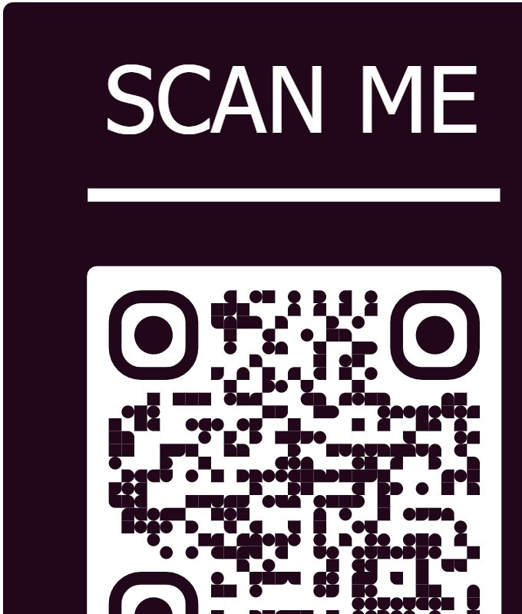
3. Suggestions for improvement (if any):

Organizations’ Feedback form after activity
Section A: Organization Details
- Organization Name:
- Address:
- Contact Person Name & Designation:
- Contact Number / Email:
- Title of Student Project/Activity:

- Date(s) of Activity:
Section B: Feedback on Student Engagement (Please tick Yes/No)
Sr.  No | Question | Response
Sr.  No | Question | Yes | No
1. | Were the students punctual and professional during their engagement? | ☐ | ☐
2. | Did the students clearly communicate the purpose and objectives of  their activity? | ☐ | ☐
3. | Was the activity relevant to the needs of your organization/community? | ☐ | ☐
4. | Did the students demonstrate teamwork and collaborative behavior? | ☐ | ☐
5. | Were the students respectful of your organizational norms and cultural  values? | ☐ | ☐
6. | Would you be willing to collaborate with our institute for future  activities? | ☐ | ☐
Section C: Quality of Activity
(Please rate on a scale of 1 to 5: 1 – Strongly Disagree, 5 – Strongly Agree)
Statement | 1 | 2 | 3 | 4 | 5
The project/ activity addressed a real need of the community/  organization. | ☐ | ☐ | ☐ | ☐ | ☐
The activity had a positive impact on the target participants. | ☐ | ☐ | ☐ | ☐ | ☐
The students showed creativity and initiative in executing the project. | ☐ | ☐ | ☐ | ☐ | ☐
The activity was well-planned and effectively implemented. | ☐ | ☐ | ☐ | ☐ | ☐
The collaboration with students added value to your organization/  community. | ☐ | ☐ | ☐ | ☐ | ☐

Section D: Overall Feedback
- How would you rate your overall satisfaction with the student engagement?  - Excellent ☐ Good ☐ Average ☐ Poor | Oragniser’s feedback  Submit soft copy
2. What specific benefits did your organization/ community gain from this project? | 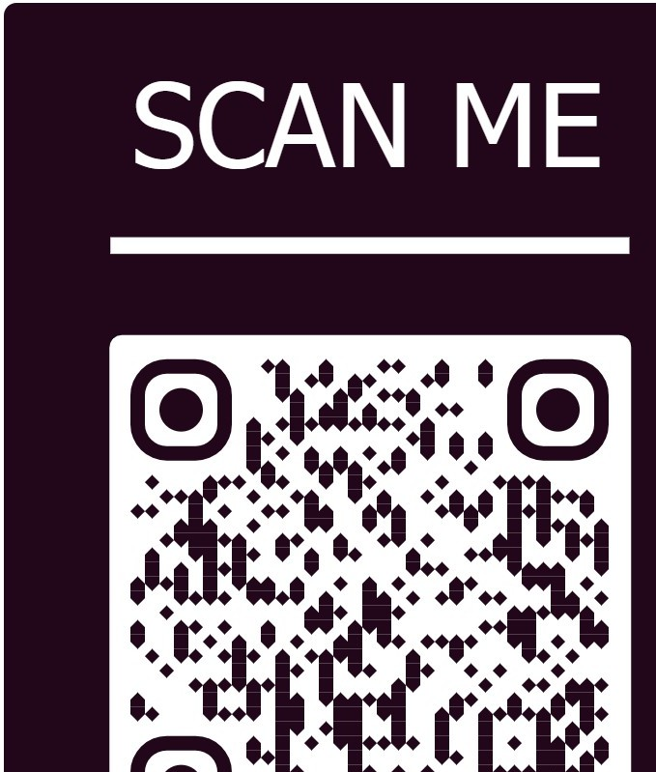
3. Suggestions for improving such projects in the future:
4. Any additional comments:



CERTIFICATE OF COMPLETION

This is to certify that Mr./Ms.………………………………………………………. With roll number …………………...from SCTR’s Pune Institute of Computer Technology (PICT), Class SY B. Tech has successfully completed the COMMUNITY ENGAGEMENT PROJECT activity titled “……………………………………………………………………………………………
………………………………………………………………..” for the duration starting date - ending date, number of hours…………… in our organization/ Institute ………………………………………………………………... at…………………… as a part of SY B. Tech curriculum We are pleased to offer this certificate for active participation and contribution to our institute/ organization for valuable information and knowledge sharing.

Sign Sign
Name of Course Teacher Name of the Head
Assistant Professor, Dept. CE Designation
SCTR’s PICT, Pune Name of Organization

Undertaking/ Consent form for student and parent for participation in Community Engagement Project (CEP)
We, the undersigned student and parent/ guardian, hereby give our consent to participate in the Community Engagement Project (CEP) activities conducted by the college. We understand that these activities may be carried out at external organizations with prior approval and necessary permissions from both our college authorities and the host institution.

We undertake to follow all etiquettes, discipline, and proper conduct during the activities. We acknowledge that the college will not be held responsible for any misconduct, misbehavior, or inappropriate actions by the us at the host organization.
We also agree that all expenses, including travel, food, or any other costs related to the activity, will be borne by the us, and the college shall not be liable for any such financial commitments. However, the college will facilitate and extend all possible support and assistance required for the smooth conduct of the activity. Furthermore, the college will follow safety norms and precautionary measures to avoid incidents, or unforeseen events beyond its control occurring during the activity.
We understand that attendance for CEP will be considered only when the student reports and obtains prior approval from the concerned course teacher. Activities conducted without prior intimation will not be counted towards attendance.
Students are encouraged to utilize Saturdays, Sundays, and post-college hours on working days effectively to conduct these activities. However, they shall report to course teachers once in a week to update status of work carried out.
We hereby provide our consent to abide by the above terms and conditions.
Date:

Name: Name:

Student’s Name & Signature Parent/ Guardian’s Name & Signature
Mobile No. Mobile No.

Email address: (parent and student)

Note: Student’s living at hostel/ private rooms may request parent to send signed copy through email to respective course teacher.

Tear out this page an submit hardcopy.

On college letter head/ Department letter
Ref: PICT/E&TCE/2025/CEP_E5_1/12
To
Name of the Authority/Head Designation
Organization Name Address

Subject: Request for Permission to Conduct a Activity Name at Organization Name under Community Engagement Project (CEP) as per National Education Policy (NEP2020)
Respected/ Dear [Recipient’s Name],

Greetings!!! from Pune Institute of Computer technology, Pune

Pune Institute of Computer Technology (PICT), established in 1983 and affiliated with Savitribai Phule Pune University (SPPU), is a premier autonomous engineering institute specializing in Computer, Electronics & Telecommunication, IT, AI & Data Science, and Electronics & Computer Engineering. We emphasize innovation, research, and holistic student development through strong industry collaborations and academic initiatives.
As part of our outreach efforts, our students and faculty are undertaking a Community Engagement Project integrating social, technical, and socio-technical activities to benefit the community while enriching students' learning.
We kindly seek your permission to conduct this activity at [Organization Name/community location. The activities will be conducted under the guidance of [faculty name], ensuring meaningful outcomes and alignment with your community’s needs.
We look forward to your support and collaboration for this initiative. For any details or suggestions, please contact [Name, faculty coordinator phone/email].
Thank you for considering our request. Sincerely,

1Name of Student | Sign | Sign
2Name of Student | Sign | Name of Course Teacher
3Name of Student | Sign | Assistant Professor,
4Name of Student | Sign
5Name of Student | Sign
 | Dept. CE, SCTR’s PICT, Pune

Report format
- General Instructions
  - Report Length: 10–15 pages (excluding annexures).
  - Format:
    - Font: Times New Roman, Size 12
    - Spacing: 1.5 line spacing
    - Margins: 1 inch on all sides
    - Alignment: Justified
  - Referencing: Standard referencing style as per IEEE.
  - Figures & Tables: Numbered (e.g., Fig. 1, Table 1) with captions.
  - Plagiarism: Should not exceed 15%.
  - Submission: Soft copy (PDF) + hard copy tape-bound.
- Report Structure Cover Page
  - Institute Name & Logo
  - Title of the Project
  - Names of Students (with PRNs)
  - Faculty Mentor Name
  - Host Organization/Community Name (if applicable)
  - Academic Year & Semester Acknowledgment
  - Thanking host organization/community, mentor, and institute. Abstract (150–200 words)
  - Brief overview of problem, objective, methods, and key outcomes. Table of Contents
  - List of sections, tables, figures, and annexures.
- Introduction
  - Background of the community issue/problem.
  - Relevance of the project (why it matters).
  - Alignment with UN SDGs (if applicable).
- Objectives
  - 3–5 clear objectives of the project (aligned with CEP course objectives).
- Literature/Context Review
  - Brief review of previous efforts/approaches to the problem.
  - Role of engineering in solving such community issues.
- Methodology (Project Planning & Execution)
  - Group formation & roles of members.
  - Stakeholder engagement (community/organization).
  - Timeline of activities (Gantt chart if possible).
  - Resources used.
- Implementation / Activities Conducted
  - Step-by-step description of activities conducted.
  - Photos (with captions & consent).
  - Any tools/technologies used.
- Outcomes & Impact
  - Tangible (quantifiable results: number of people impacted, etc.).
  - Intangible (skills gained, awareness created).
  - Feedback from community/organization (attach summary).
- Reflection & Learning
  - What did the students learn?
  - Challenges faced & how they were addressed.
  - Scope for future work.
- Conclusion
  - Key takeaways and overall summary of project success.
- References
  - Standard referencing style as per IEEE.

- Annexures
- Project proposal (approved version).
- Feasibility Study report
- Logbook (summary).
- Achievements if any (certificates/ recognitions)
- Host organization feedback form.
- Geo Tagged photos of activity, list names of the person below photo, and location
- Video links if any to be shared (students will keep it on their drive and paste sharable links here).
- Presentation slides (if any).
- Evaluation and Assessment Rubrics
Criteria | 5 – Excellent | 4 – Very Good | 3 – Good | 2 – Fair | 1 – Poor
1. Problem | Clear, well- | Relevant and | Adequate | Vague or | Irrelevant or
Identification | researched, | mostly well- | problem with | partially relevant | poorly defined
& Social | highly | researched | limited research. | problem. | problem.
Relevance | relevant | problem.
(20%) | problem
 | aligned with
 | objectives.
2. Planning, | Comprehensi | Good plan and | Adequate plan; | Weak | No proper
Execution & | ve plan; | execution; | some execution | planning/executi | planning;
Teamwork | effective | effective | issues; basic | on; poor | incomplete
(20%) | execution; | teamwork. | teamwork. | coordination. | project; no
 | excellent |  |  |  | teamwork.
 | teamwork &
 | conduct.
3. | Strong, | Good impact | Limited | Minimal impact; | No visible
Community | measurable | with moderate | outcomes; basic | poor | impact or
Engagement | impact; high | engagement. | one-way | engagement. | stakeholder
& Impact | stakeholder |  | engagement. |  | involvement.
(20%) | participation;
 | mutual
 | respect.
4. | Creative, | Relevant | Basic | Poor application; | No meaningful
Application | appropriate | application; | application; | impractical or | application; non-
of | application; | mostly feasible | partially | incomplete | functional
Engineering | complete, | solution. | implemented; | solution. | solution.
Knowledge | feasible, |  | low scalability.
(20%) | scalable
 | solution.
5. | Clear, | Good | Acceptable | Poorly structured | Unclear,
Documentati | detailed, | report/presentati | report/presentati | or incomplete | incomplete, or
on & | well- | on with minor | on with limited | report/presentatio | missing
Presentation | structured | issues. | depth. | n. | report/presentati
(20%) | report; highly |  |  |  | on.
 | professional
 | presentation.
Template may be shared by respective course teachers.

